**Instructions for Instafood app compilation**

Get started:

1. Please download the demo app project. To start, Click [here](https://www.instamobile.io/app-templates/food-app-template/).
   1. Press DOWNLOAD > PROCEED TO CHECKOUT.
   2. Enter your first name and email address, and press continue after entering.
   3. Press on FOODAPPV1 for downloading the project in the zip folder.
   4. Extract the files to where you want.

Run Expo and Metro Bundler:

1. Open a terminal/command line/editor with terminal (e.g., Visual Studio Code) and navigate (with cd(Windows)/move(Mac) command to where the extracted files are located.
   1. In the terminal, move to a file called "recipes-app-react-native" and always stay there.
   2. This is an expo app, so to make sure that app runs as Expo, run in the terminal/command line the following command: npm install (if expo does not exist, run the following command: npm install expo). After installation, the app can run as an Expo app.
   3. Now let’s run the app as Expo with the following command: expo start.
   4. Now the Metro Bundler (server) is running and the app is running as an Expo app (The server runs on your localhost address). **Important! Don't close the Metro Bundler and the terminal/command line until the entire process ends. For the next commands, open another terminal in the same path.**

Preparations to generate APK:

1. Before generating an APK, we need to do two things: configure Expo in our app and open an Expo account.
   1. Configure Expo in the app:
      * Go to this [link](https://docs.expo.io/distribution/building-standalone-apps/#1-install-expo-cli) and go to Step 2, "Configure app.json", move to gray square below and copy all the words that marked in image below.

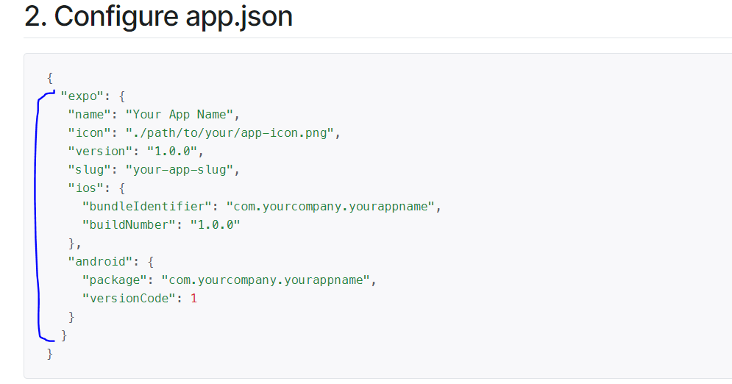

* + - Open the package.json file in your project and paste the copied text there.
      1. Make sure that the pasted content is outside of the two curly brackets.
      2. You have a comma before and after the pasted content, see blue marks in the image below:

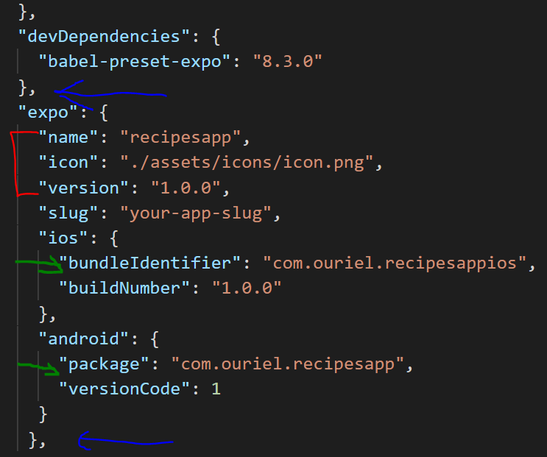

* + - **Pay attention:** 
      1. **name, icon and version** are required. It is recommended to change their values to something more appropriate to your app, which means: change app name, change icon by navigating path to an image that exists in your app, and keep track of this app version and write the right version of your application. See red marks examples in image above.
      2. **bundleIdentifier (“ios”) and package (“android”)** - you need to change their values to something appropriate to your app. See the examples marked in green in the image above.
  1. Expo account:
     + Go to this [link](https://expo.io/) ,
       1. If you already have an account, just sign in.
       2. If you don’t, sign up.

Generate Android APK:

1. Now open another terminal/command line in the same path that the project is located (it’s needed because we have another terminal/command line for Metro Bundler running).
   1. Type the command – expo build:android.
   2. Navigate with keyboard arrows and choose apk option, see here:

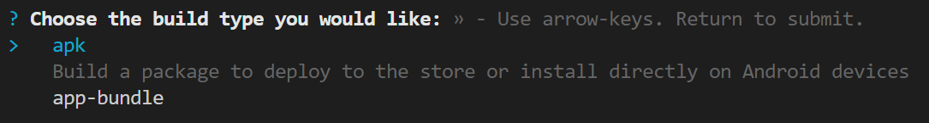

* 1. If you are not logged in, the menu requires you to enter your email and password to log in to Expo account
  2. Now the application build is done automatically, and at the end of the process, we will have the APK.

**NOTE:**

* + - The process takes some time so make a coffee or something 😊
    - You don’t need to save the open terminal; the build is automatic**.**
    - You can monitor the build process by opening the link shown in the following image:

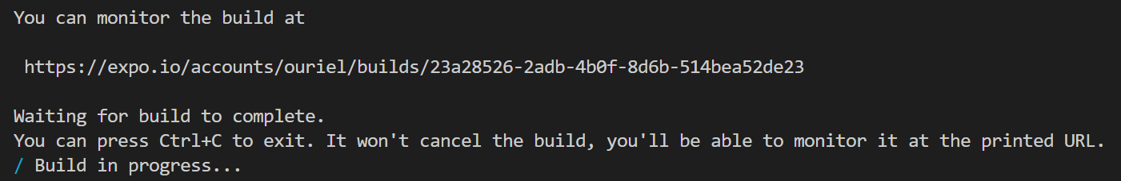

* + - Alternatively, you can monitor the build process by opening your Expo account and pressing on the builds tab. See the image below

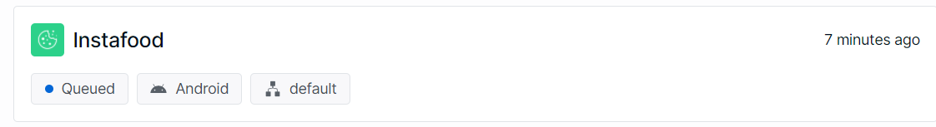

* 1. After the build is finished, we can see how it look like in the following images:
     + In expo account:

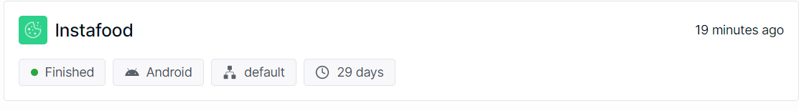

* + - On terminal/command line, press on link to the reach the app (it’s the same as the option above):



Now our APK is ready. Let’s press on our app tab in our Expo account, and move down on the screen.

Now we see the build artifact, and we want to download the APK. Press on the download button (marked in green) **and we have an APK**, see image below:

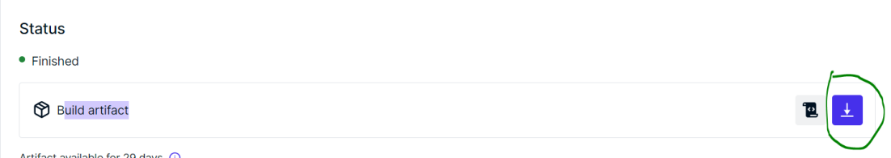

**THIS APK CAN BE SENT TO SIMULATORS OR ANDROID PHONES FOR APP INSTALLATIONS!**

**WE ARE DONE! :)**

Generate IOS APK:

1. Now open another terminal/command line in the same path that the project is located (it’s needed because we have another terminal/command line for Metro Bundler running).
   1. Type the command – expo build:ios.
   2. Navigate with keyboard arrows and choose simulator option, see here:

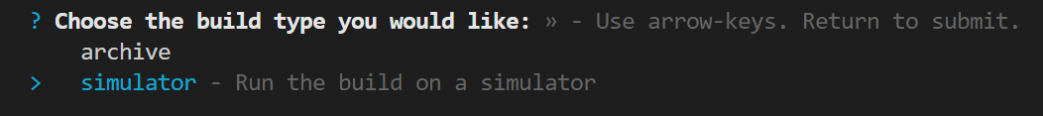

**Important: Now repeat levels c-e like in android generate APK instructions, with one little change, THE DOWNLOADED FILE IS A zip OR gz FILE, THAT IS NOT THE APK, THE APK IS THE EXTRACTED FILE FROM zip/gz FILE AND ITS SUFFIX IS .app, THIS IS THE APK.**

**THIS APK CAN BE SENT TO SIMULATORS OR IOS PHONES FOR APP INSTALLATIONS!**

**WE ARE DONE! :)**